9th Oct 2019
PROJECT DESCRIPTION

Project Title: Eastern cooperatives for beekeepers Uganda

Project Proponent/s: Eastern Honey Pride Uganda

Beneficiaries: 400 farmers and their households

Contact person: Miss Maltina Nabeta

Contact address: PEFO, Budondo, Jinja

Tel: 0700362552
Postal address P.O BOX 1412
Email address: maltinanabeta@gmail.com
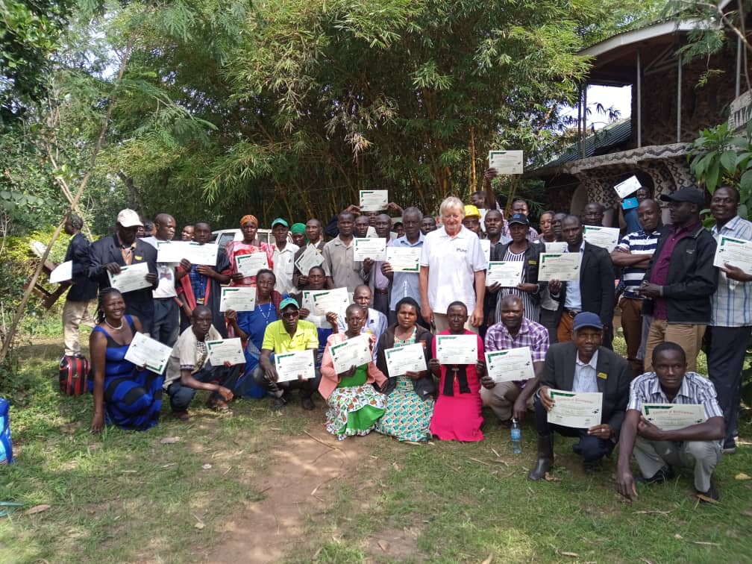
3 day Training beekeepers at Busaino Fruits, Bugiri, Jinja area.

EXECUTIVE SUMMARY
Beekeeping is emerging as a very successful agricultural practice for local people in rural areas of less developed countries. Not only does the practice of beekeeping have intrinsic health benefits through providing a food source of great nutritional value which is lacking in rural areas, but beekeeping requires few inputs and capitalizes on a ready supply of pollen. In rural areas there is almost an unlimited source of pollen and bees aid greatly in the natural cross pollination of local crops. Health benefits for local people reliant on small agriculture to provide food are centered around the enriching qualities of honey in a diet which is usually dependent upon staple foods such as bananas and maize.

In a country where the average per capita income is US $ 324 beekeeping represents a viable microeconomic enterprise which pays for itself in the first year, provides health benefits and is a practical insurance against crop failure and local unemployment. There is major potential for grassroots poverty alleviation and empowerment of local people through the practice of beekeeping.

This project aims to establish an umbrella organization to give support to the farmers, give training, advisory and financial support, protect and keep the environment in good conditions as farmers will be encouraged to grow trees that are useful in beekeeping.
Farmers will be trained on beekeeping skills, after the training, bee hives and the required tools for beekeeping will be given to a group of farmers (5 farmers per group) which they will take to their farms and start beekeeping. However, after a certain period of time i.e. 3 years, farmers will be required to pay back money for bee hives and the other equipments that were given to them after the training.
Eastern Honey Pride (EHP) will then process their honey and market it for them.
The major goals of this project are hence twofold: to provide a new stream of income for the farmers together with their partner organization Dutch Foundation, and to alleviate poverty through the training and support of local people in the practice of beekeeping.
The Foundation will give technical support about bee keeping, how to organize and to manage an apiary, working with the KTB. Further financial supply will also be availed. Financial supply means: Dutch Foundation will supply money for investment for groups of six bee keepers. They need to share equipment, because of financial efficiency.
Smokers, beekeepers overalls, pair of gloves, hive tools (non rusting), gum boots, bee brush, , air tight buckets and KTB will be given to farmers.
In regard to bee hives, we will introduce a system of leasing. Bee keepers must pay two times a year instalments without interest. Duration of three years by providing honey every season of harvesting honey. The amount of honey supplied by the farmer will be equated to money hence clearing the loan given to them.
We shall introduce record keeping for each individual farmer. The beehive has a serial number that does belong to the individual farmer.

VISION:
Economic empowerment of people and support from the Dutch Foundation through the widespread introduction of beekeeping throughout Eastern Uganda.
MISSION:
To empower local people with skills in beekeeping, as a way of addressing rural poverty and general health issues.

GOALS AND OBJECTIVES:
- To establish a Limited Company by Guarantee as umbrella organization to give support to the farmers, give training, advisory, financial support; protect the environment in good conditions where farmers will be required to plant trees necessary for beekeeping.
- To establish a center of collection and processing honey in Busia.
- To people planet and plant ie preserving mother nature
- To introduce beekeeping to the local farmers as a way of providing a personal source of income to them hence reducing the poverty levels.
- Improvement of local health standards through the use of bee products such as honey and propolis.
- To provide market for honey produced by the different local farmers.
- To establish an innovative model of microeconomic enterprise which can be replicated in other parts of Uganda.
- To establish training grounds where farmers can access training for beekeeping and managing an apiary.
- To promote EHP as the leading producers of honey in Uganda.
- To promote other bee products like bee wax, pollen grain, propolis, bee venom,
- To establish a point of sale for honey in Jinja
- To provide employments to the youth through working on the processing units.

Business model and value proposition:
Apiculture is a powerful way of tackling poverty at the grassroots level. EHP in partnership with the Dutch Foundation is looking to establish an umbrella organization for beekeeping as a platform for equipping local farmers with the necessary skills for beekeeping and managing an apiary for business.
The umbrella organization will be looking for different places where the training will be held. PUM (Dutch Senior Experts) will be sent to hold the training.
The Dutch foundation will provide food and drink for the farmers during the training. Local women will prepare food that will be provided in the training.
The umbrella organization will as well be harvesting honey for sale; farmers will also be bringing their honey for processing and sale at EHP hence making honey the main source of income for EHP. The first center will be established in Busia.

Product / Service:
EHP will be harvesting honey from the apiary, take it for processing and packaging in Busia, it will then be taken for sale to consumers.
It’s important to note that honey has been recommended by the doctors as one of the health products need by a person to consume. Doctors have discouraged the use of sugar in tea and encouraged people to take honey instead hence making it a health product.

1.3 Market structure and analysis:

a) Target market and customer base

The market is very wide, and demands good quality of honey and its related products. The market includes, The hive Uganda, Jalja supermarket, household, Jinja hospital, Source of the Nile hotel.
These customers are able to pay 20,000 for 1 kg of honey. EHP will have a wide variety of customers. These include from household, restaurants, hospitals, hotels, pharmaceutical companies which use the propolis as a raw material for making tablets, schools,

1.4 Marketing and distribution:
a) Marketing & Communication
One of the marketing tools will be done at the 3 days training in Busia and Mayuge centre of excellence during the training. Farmers will be told about EHP, how it will be helping them eradicating poverty in their homes by giving them a source of income in their homes i.e. they will be given bee hives and the necessary tools needed for the apiary that they will set up at their farms.

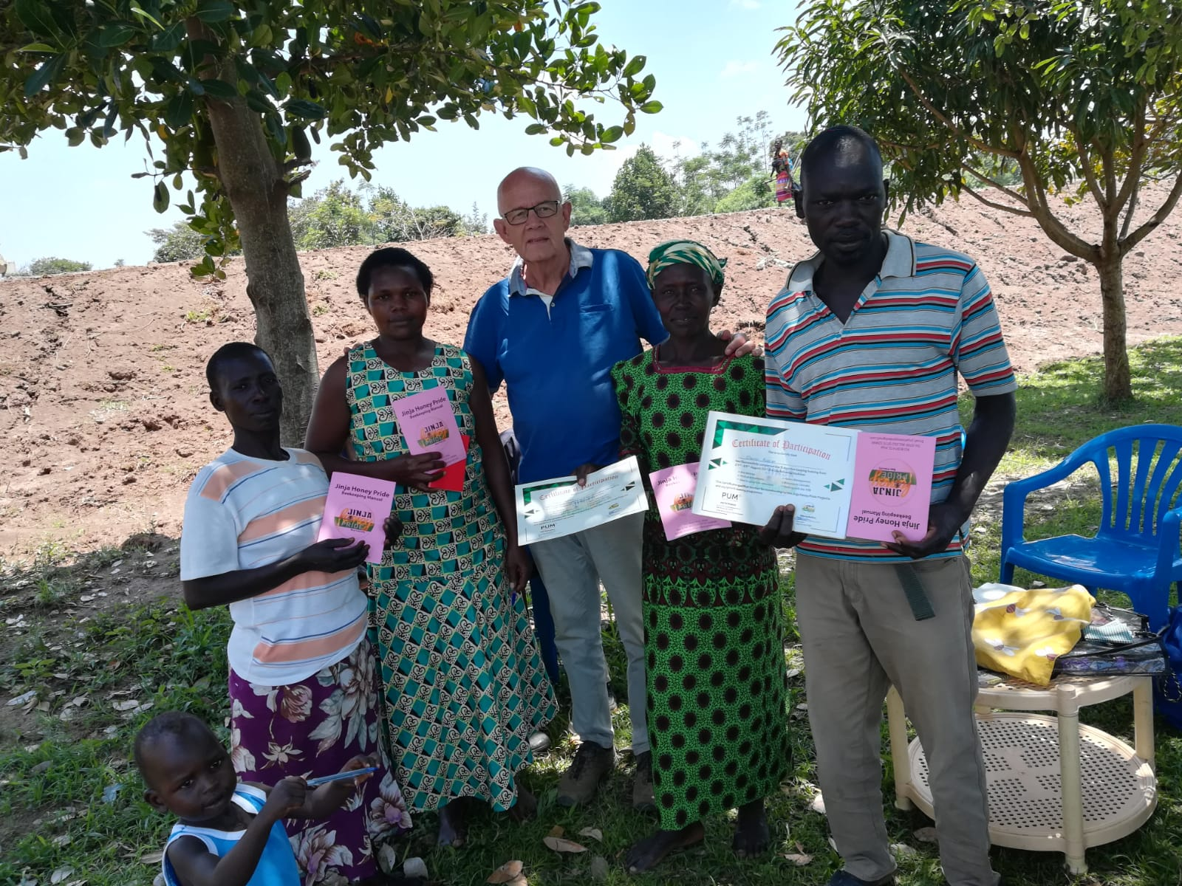
Distribution of the manuals to beekeepers with a certificate.

Other marketing and communication tools include; pull up banners, tear drops, posters, flyers, brochures, branded T. Shirts that will be used during the training at both Busaino fruits and PEFO.
Social media platforms will also be used for marketing and communication.

b) Distribution
EHP, at a later stage will have a shop in Jinja because it’s a place of tourism like the source of the Nile, which will be our point of sale for its honey and any other bi product that it will be producing at a later stage.
We will choose a given location in Jinja where we will set up the shop for EHP products.

1.5 Production process & development:
When honey is ready for harvesting, it will be taken to a particular point (which will later be identified) for processing using the modern tools that JHP will acquire.
Honey will then be processed and packaged for sale and distribution in the market.

1.6 The suppliers and raw materials:
EHP will be working with 3 different stake holders, all of which will be playing different roles. These include;
- Equip or Pefo. All the beehives will be manufactured from here on order.
- Farmer cooperatives. Our current stake holders are 14 groups, but as times go on, we will increase.
- PUM Netherlands Senior Experts
- Dutch foundation for promoting bee keeping in Ugandans
- Nabbongo Agri enterprise ltd will be mobilising farmers who will be attending the training for beekeeping.

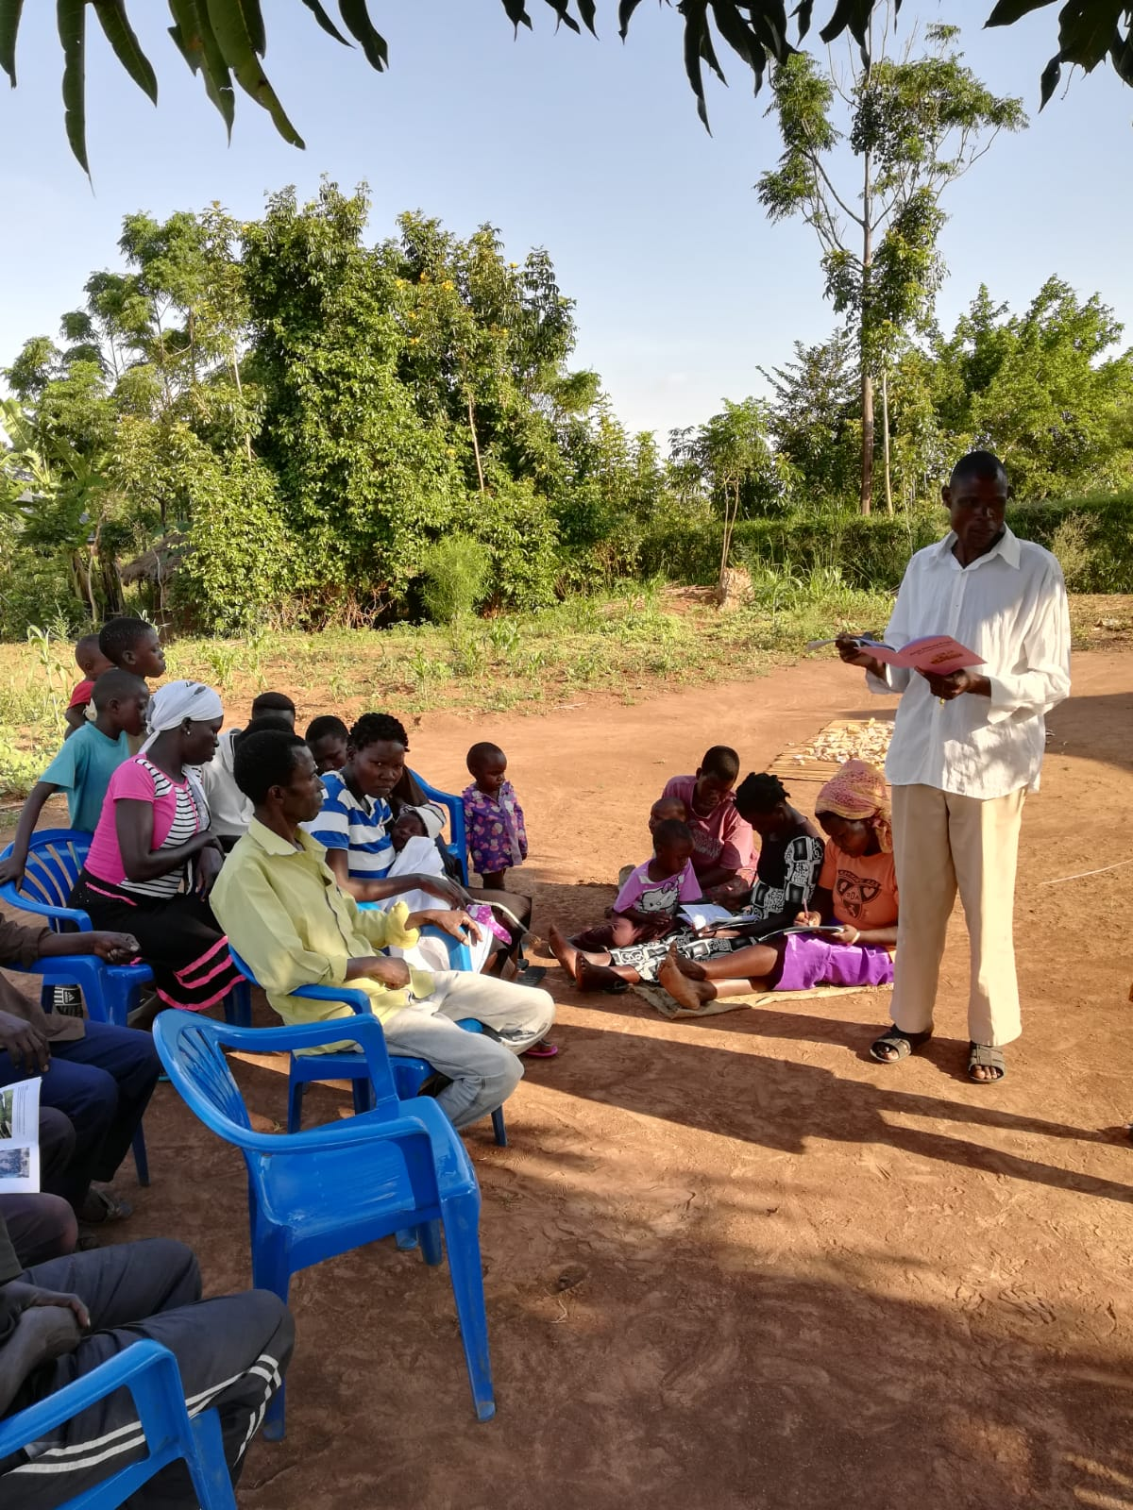
Sharing experience about the training and key issues.

1.7 Company structure & management:
a) Management team
Since EHP is still a pilot project; we will employ one part time manager, community mobilisers, who will be running all the activities of EHP.
At a later stage, when EHP is established, more staff will be employed hence making up a full management team.
However, below is the current organogram which JHP will be operating on;

EHP ORGANOGRAM

Limited Company by guarantee

Manager
JHP

EQUIP
Farmer coorperatives

Dutch foundation
Dutch
Foundation

- The founder will be,
Miss Nabeta Miriam Maltina.
- The executive board will include,
- Theo Sinke, Financial expert and chairman of the board.
- Piet de Meester, beekeeper by profession.
- Lydia Namukomazi, a lecturer from AFRISA
- Opio Wilfred, beekeeper and business maker.

- The manager of Eastern Cooperative for beekeepers,
Miss Nabeta Miriam Maltina.

b) Partners and sponsors
Our main sponsor will be the Dutch Foundation For Supporting Beekeeping in Uganda. These will give us both technical and financial support for the project.
Our partners will be the farmer cooperatives and PEFO. We will be working with our stakeholders who have already been selected, clearing identifying their role in this project. We visited these farmer cooperatives in districts of Namayengo, Busia, Bugiri, Mayuge, lunyo and Iganga.

Equip carpentry workshop from PEFO will produce all necessary tools and beehives according an agreement in regarding to prices and quotation.
Look at www.pefoug.org
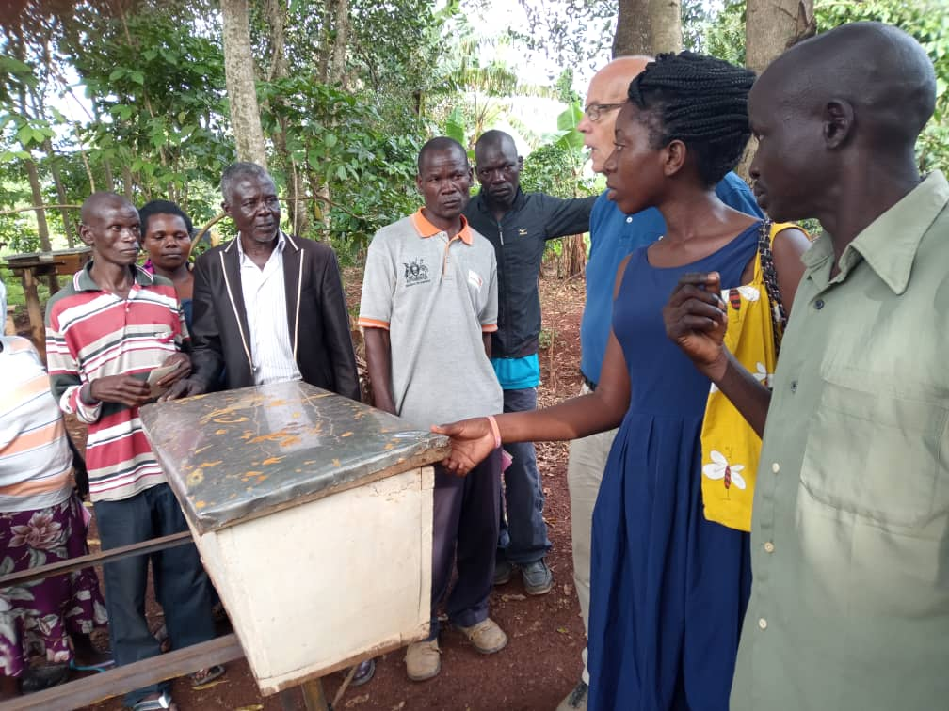
Teaching about the advantages of a Kenya Topbar Beehive [KTB]

c) Legal status
Our project will be commercialised and registered under a Limited Company by guarantee.
With the help of a lawyer, all the documents and paper work will be done by him. He shall be able to process for JHP all the paper work needed to start the business.

1.8 Milestones and strategy
A lot of goals have been set for JHP. These include:
- Design a plan of action within targets, activities and markets.
- Looking for financial funding from Dutch Foundation.
- To establish an umbrella cooperation
- To organize trainings in the field
- To get admission by legal status/license.
- To buy equipment and necessary or processing tools.
- To start marketing and communication.
- To organize sustainable partnerships.
- To visit proposed customer
- To start up a shop

1.9 SWOT analysis
STRENGTHS | WEAKNESSES (internal risks)
- Wide market for honey and its bi products.  - Skilled and experienced staff  - Reliable partners like Dutch Foundation who will support the project both financially and technically.  - Very high gross margins.  - Ability to sell online  - Limited start up risks.  - The sector is prioritized by Uganda government.  - Availability of improved bee hives. | - High transport costs.  - Limited flexibility in pricing.  - Lack of access to credit facilities.  - High costs in setting up the processing machines.
OPPORTUNITIES | THREATS (external risks)
- Ability to develop bi products like candles, wax, propolis, shoe polish.  - Expanding regional market for honey and its bi product.  - Availability of land.  - Poverty alleviation.  - There is opportunity for establishing coordination between bee keepers collecting centers and potential purchasers. | - Inadequate infrastructure which makes transport costs very high.  - Deforestation which has reduced the number of trees in a given area.  - Loss of habitat for bees.  - Loss of bees from pesticide use.

REFERENCES
- Piet de Meester
Poppendamseweg 3
4364 SL Grijpskerke
Netherlands
M 06 13999917

- Theo Sinke
Chairman Dutch Foundation
Netherlands
+31118592656

Homepage; www.bijenteelnoorduganda.nl
Emailaddress: info@ bijenteelnoorduganda.nl

- Mugerwa Athanasius Tana
Animal husbandry office
Busia district local govt
+256752308519, +256772308519

